Kenwood Academy Fun Facts
Organized January 9, 2004 where 10 seniors provided peer mentoring to 25 freshmen.
Ultimate goal is to close the Achievement gap of Males of Color and increase the 39% graduation rate of CPS males of color
Brotherhood Alumni Foundation formed May, 2007
Alumni Foundation becomes 501 c 3 not for profit charitable organization February, 2012.

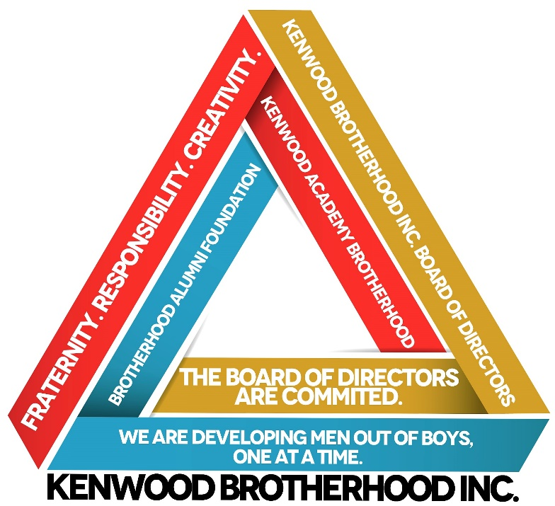
7 Steps to Create a School Based Male mentoring organization
1. Assess for Need
2. Find Motivated Adults
3. Create Mission/Purpose
4. Create a Creed/Code of Honor
5. Recruit Members
6. Create Program of Engagement
7. Collect Success DATA

7. Collect Success Data
Helped Long Beach Unified School District to create Male Academies as a platform to combat racial conflict issues.
Publications:
The Brother’s Key- 2005
ASCA mentoring manual – 2009
The Brother’s Key – Part 2 in production
30 week Holistic Curriculum
ASCA Mindset Standards
Nguzo Saba Tenets
Pablo Freaire’s Empowerment Theory
KAB Cultural Comprehension

Graduate school Counseling, Psychology, and Social Work Interns provide weekly Mental Health Checkups
2010-present
500-700 Males have been involved in the organization
Coordinated the Chicago Public Schools Male Initiative Project with DePaul University to create school based male mentoring organizations in local elementary and high schools.
2006
National Presentations
American School Counselor Association
National Alliance for Black School Educators
The College Board
Dream Deferred
White House Convening
National Mentoring Summit

